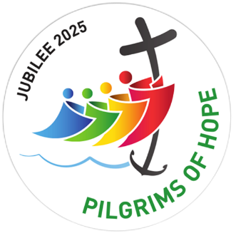
Jubilee Year 2025: Pilgrims of Hope
A letter from the CES Chairman, the Rt. Rev. Marcus Stock
I am writing in the light of Pope Francis’ request that the global Catholic community celebrate a year of Jubilee in 2025, entitled Pilgrims of Hope. In this landmark moment in the life of the global church, we are invited to celebrate the Jubilee year with “deep faith, lively hope and active charity.” The theme of Jubilee 2025 is Hope: the hope that comes from knowing we are loved by God, the hope we can bring to those in most need, and the hope we can bring to our common home, the earth. There will be opportunities for the whole school community to experience the joy of sharing their faith in prayer and worship, and take action together as pilgrims of hope “in service to God’s kingdom of love, justice and peace.”
The Holy Year is an opportunity to offer “signs of hope” to our world: hope for peace, hope for the transmission of life, hope for those who are in prison, hope for the sick, for the young, for migrants, for the elderly, for those who are poor. The goods of the earth “are not destined for a privileged few, but for everyone.” No one should go without what they need for a dignified life, no one should live without hope.
Alongside any plans offered by your own dioceses, a framework for schools to plan and celebrate the Jubilee year will be offered by three of the agencies of the Bishops’ Conference of England and Wales: the Catholic Education Service, CAFOD, and Caritas Social Action Network, with support from CYMFed. This framework will enable our Catholic schools and colleges to embark on a shared journey and mark this Holy Year as a significant and memorable moment in the lives of children and young people.

Friday 24th January 2025 - Jubilee Launch Day for Schools and Colleges
Since the Jubilee begins on 24th December 2024, when educational institutions will be closed for their Christmas break, we will organise a Jubilee launch for schools and colleges on 24th January 2025. The Gospel reading for this weekend is a foundation text for the Jubilee Year, where Jesus, reading from the Book of the Prophet Isaiah, proclaimed good news to the poor, sight for the blind, and freedom for the oppressed (Luke 4: 18-36).
Journeying through the year together, there will be an opportunity also for school and college communities to make a Jubilee Pledge, a long-term commitment to the common good and look outwards, advancing justice and harmony. In the light of this commitment, there is also an invitation to refresh and renew the mission statement of their school or college.
Friday 21 Nov 2025 – Jubilee Celebration Day for Schools and Colleges
Towards the end of the Jubilee year, we will join together in celebrating our shared journeys of “deep faith, lively hope and active charity”, looking to the future with renewed hope and commitment.
Rooted in the Old Testament, the celebration of a Jubilee has always been a time of reconciliation and renewal, where equality was restored to all God’s children, slaves were set free, debts were cancelled, and the land was allowed to rest and recover. It is an invitation for a special encounter with Jesus, the “door” of our salvation, and an opportunity to re-establish a proper relationship with God, with one another, and with all of creation. We are called upon to live out Catholic Social Teaching: to be agents of justice and peace, to act where human beings are tied down by poverty, loneliness, exclusion, discrimination, suffering of any kind, to restore dignity and hope and to challenge the causes of poverty.
Pope Francis reminds us that for Christians, happiness is not some fleeting pleasure that keeps us longing for more, but rather, “We aspire to a happiness that is definitively found in the one thing that can bring us fulfilment, which is love. Thus we will be able to say even now: I am loved, therefore I exist; and I will live forever in the love that does not disappoint.”
For the children and young people in our schools, and for the rest of society, this is the message of Jubilee 2025. Life is not hopeless, despite its challenges. Life is the gift of a loving God who calls us in Christ to love, peace and justice in this world, and eternal communion with him in the next.

Rt Rev Marcus Stock
Bishop of Leeds,
Chair of the Department of Catholic Education & Formation
Chair of the Catholic Education Service

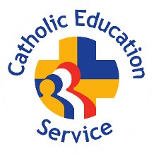

Pope Francis, Letter to Msgr. Rino Fisichella, resident of the Pontifical Council for the Promotion of the New Evangelization, for the Jubilee 2025
Message of His Holiness Pope Francis for the 61st World Day of Prayer for Vocations, 21 April 2024
Pope Francis, Spes Non Confundit, Bull of Indiction of the Ordinary Jubilee of the Year 2025, 16
Ibid., 21

